**PROJECT-II REPORT**

**On**

**SPAM DETECTION USING BIG DATA**

**& MACHINE LEARNING**

Submitted to Rajasthan Technical University

in partial fulfillment of the requirement for the award of the degree of

**B.TECH.**

**in**

**COMPUTER ENGINEERING**

**Submitted By**

**Aayushi Bhatt (PIET15CE003)**

**Vibhor Bhimsariya (PIET15CE118)**

**Unnati Singhal (PIET15CE115)**

**Under the Guidance of**

**Mr. Deepak Moud**

at



**POORNIMA INSTITUTE OF ENGINEERING & TECHNOLOGY, JAIPUR**

**Rajasthan Technical University, KOTA**

**APRIL, 2019**

**CERTIFICATE**

This is to be certified that the project entitled “**SPAM DETECTION USING BIG DATA AND MACHINE LEARNING** ” has been submitted for the Bachelor of Computer Science and Engineering, Poornima Institute Of Engineering & Technology, Jaipur during the academic year 2018-2019 is a bonafide piece of project work carried out by “ **Aayushi Bhatt, Vibhor Bhimsariya & Unnati Singhal** ” towards the partial fulfillment for the award of the Degree (B.Tech.) under the guidance of “**Mr. Deepak Moud**” and supervision and no part of thereof has been submitted by them for any degree or diploma.

Project Guide Project Coordinator Mr. Deepak Moud

Mr. Deepak Moud Prof. (Dr.) Praveen Gupta (H.O.D., CSE)

(Assistant Professor) (Professor)

**CANDIDATE’S DECLARATION**

We, **Aayushi Bhatt (PIET15CE003), Vibhor Bhimsariya (PIET15CE118) & Unnati Singhal(PIET15CE115)** B. Tech (Semester- VIII) of “**Poornima Institute Of Engineering & Technology, Jaipur”,** hereby declare that the Project Report entitled **“SPAM DETECTION USING BIG DATA AND MACHINE LEARNING”** is an original work and data provided in the study is authentic to the best of our knowledge. This report has not been submitted to any other Institute for the award of any other degree.

|  |  |  |
| --- | --- | --- |
| **Aayushi bhatt** | **Vibhor bhimsariya** | **Unnati singhal** |
| **PIET15CE003** | **PIET15CE118** | **PIET15CE115** |

|  |  |
| --- | --- |
| **Place:** | **Jaipur** |
| **Date:** | **23-10-2018** |

**ACKNOWLEDGEMENT**

It is our pleasure to be indebted to various people, who directly or indirectly contributed in the development of this work and who influenced our thinking, behavior and acts during the course of study.

We express our sincere gratitude to ***Dr. O. P. Sharma,*** Director, PIET for providing us an opportunity to undergo this Major Project as the part of the curriculum.

We are thankful to ***Mr. Deepak Moud, HOD, CS*** for his support, cooperation, and motivation provided to us during the training for constant inspiration, presence and blessings.

We are thankful to ***Mr. Puneet Mathur*** for his support, cooperation, and motivation provided to us during the training for constant inspiration, presence and blessings.

We also extend our sincere appreciation to ***Prof. (Dr.) Praveen Gupta*** who provided his valuable suggestions and precious time in accomplishing our Project report.

Lastly, we would like to thank the almighty and our parents for their moral support and friends with whom we shared our day-to-day experience and received lots of suggestions that improved our quality of work.

|  |  |  |
| --- | --- | --- |
| **Aayushi bhatt** | **Vibhor bhimsariya** | **Unnati singhal** |
| **PIET15CE003** | **PIET15CE118** | **PIET15CE115** |

**TABLE OF CONTENTS**

|  |  |  |
| --- | --- | --- |
| **CHAPTER NO.** | **TOPICS** | **PAGE NO.** |
|  | TITLE PAGE | I |
|  | CERTIFICATE | II |
|  | CANDIDATE’S DECLARATION | III |
|  | ACKNOWLEDGEMENT | IV |
|  | TABLE OF CONTENTS | V |
|  | TABLE OF FIGURE | VI |
|  | ABSTRACT | VII |
| 1 | **INTRODUCTION TO PROJECT** | 1 |
|  | Project Aim and Objective  Problem Statement  Background of the Project (Literature Survey)  Software Requirements  Hardware Requirements |  |
|  |  |  |
| 2 | **PRODUCT BACKLOG** |  |
|  | 1. PRODUCT Backlog 2. Sprint Backlog-1 3. Sprint Backlog-2 4. Sprint Backlog-3 5. Sprint Backlog-4 |  |
|  |  |  |
| 3 | **TECHNOLOGY APPLIED AND PROJECT MANAGEMENT** |  |
|  | Brief Description of All technology Apply in the Project.  Project management  Agile  Relevance to Society  Ethics  Life Long Learning  Project Finance  Environment and Sustainability |  |
|  |  |  |
| 4 | **PROJECT IMPLEMENTATION** |  |
|  | Sprint Backlog-1  Sprint Backlog-2  Sprint Backlog-3  Sprint Backlog-4 |  |
|  |  |  |
| 5 | **CONCLUSION** |  |
|  | Results  Conclusion  Future Scope |  |
| 6 | ANNEXURES |  |
|  | References |  |
|  | APPENDIX/ANNEXURES |  |
|  | Research Paper ( if Presented and approved for publication) |  |
|  | CV |  |
|  |  |  |

**LIST OF FIGURES**

|  |  |  |
| --- | --- | --- |
| **S. NO.** | **FIGURE** | **PAGE NO.** |
| 1. |  | 13 |
| 2. |  |  |
| 3. |  |  |
| 4. |  |  |
| 5. |  |  |
| 6. |  |  |
| 7. |  |  |
| 8. |  |  |

**LIST OF TABLES**

|  |  |  |
| --- | --- | --- |
| **S. NO.** | **TABLE** | **PAGE NO.** |
| 1. |  | 13 |
| 2. |  |  |
| 3. |  |  |
| 4. |  |  |
| 5. |  |  |
| 6. |  |  |
| 7. |  |  |
| 8. |  |  |

**ABSTRACT**

E-Mail is one of the well-known communication services in which a message is send electronically. The maximization of the digital use by different organizations has prompted the expanded utilization of Email Services. This ascent pulled in assailants, which have brought about E-Mail Spam problem. Spam messages include advertisements, free services, promotions, awards, etc. People are using the ubiquity of mobile phone devices is expanding day by day as they give a vast variety of services by reducing the cost of services and maximization of Digital Service. E-Mail is one of the broadly utilized communication service. In any case, this has prompted an expansion in E-Mail attacks like E-Mail Spam.

In this problem, preliminary results are mentioned or explained herein based on publically available datasets. This problem is further expanded using multiple background datasets.

Spam filtering is the process of detecting the unwanted or unsolicited email or text from getting into the user’s inbox. Spam filtering applications work on text filters. Text filters work by using algorithms to detect which words and phrases are most often used in the spam emails. we will build two spam classifications engine one by using logistic regression and the other by Naive Bayes. Finally, we will check the accuracy of these engines

**KEYWORDS:**

**CHAPTER 1**

**INTRODUCTION TO PROJECT**

**Project Aim and Objective:**

Providing facility of SPAM Detection to counter the fake mails as well as comparative study of the real time technology that can be used to get better and faster outcome.

**Problem Statement:**

E-Mail is one of the well-known communication services in which a message is send electronically. The maximization of the digital use by different organizations has prompted the expanded utilization of Email Services. This ascent pulled in assailants, which have brought about E-Mail Spam problem. Spam messages include advertisements, free services, promotions, awards, etc. People are using the ubiquity of mobile phone devices is expanding day by day as they give a vast variety of services by reducing the cost of services and maximization of Digital Service. E-Mail is one of the broadly utilized communication service. In any case, this has prompted an expansion in E-Mail attacks like E-Mail Spam.

In this problem, preliminary results are mentioned or explained herein based on Singapore based publically available datasets. This problem is further expanded using multiple background datasets.

**Background of the Project(Literature Survey)**

* **Organisation of work element :**

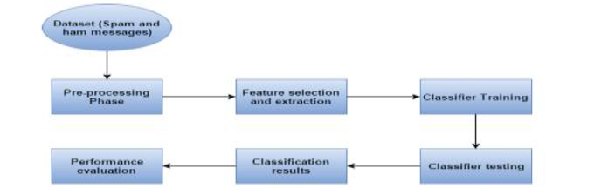

* **Methodology:**

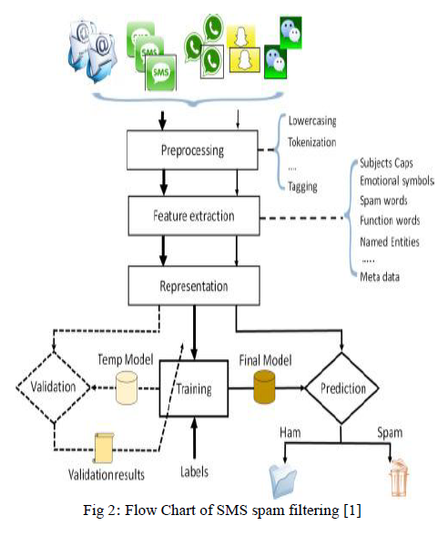

**SoftwareRequirements:**

**Hardware Requirements:**

**CHAPTER 2**

**PRODUCT BACKLOG**

1. **PRODUCT Backlog**(Half page Introduction of product Backlog and then Print of Your Existing excel sheet , including All graphs)
2. **Sprint Backlog-1**(Half page Introduction of Sprint Backlog -1 and then Print of Your Existing excel sheet , including All graphs)
3. **Sprint Backlog-2**(Half page Introduction of Sprint Backlog -2 and then Print of Your Existing excel sheet , including All graphs)
4. **Sprint Backlog-3**(Half page Introduction of Sprint Backlog -3 and then Print of Your Existing excel sheet , including All graphs)
5. **Sprint Backlog-4**

(Half page Introduction of Sprint Backlog -4 and then Print of Your Existing excel sheet , including All graphs)

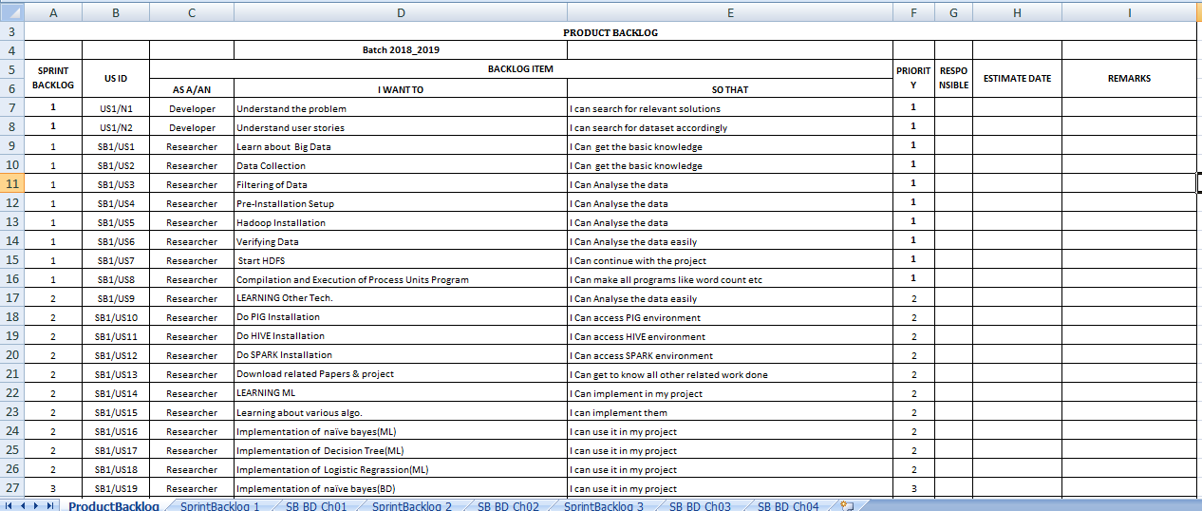

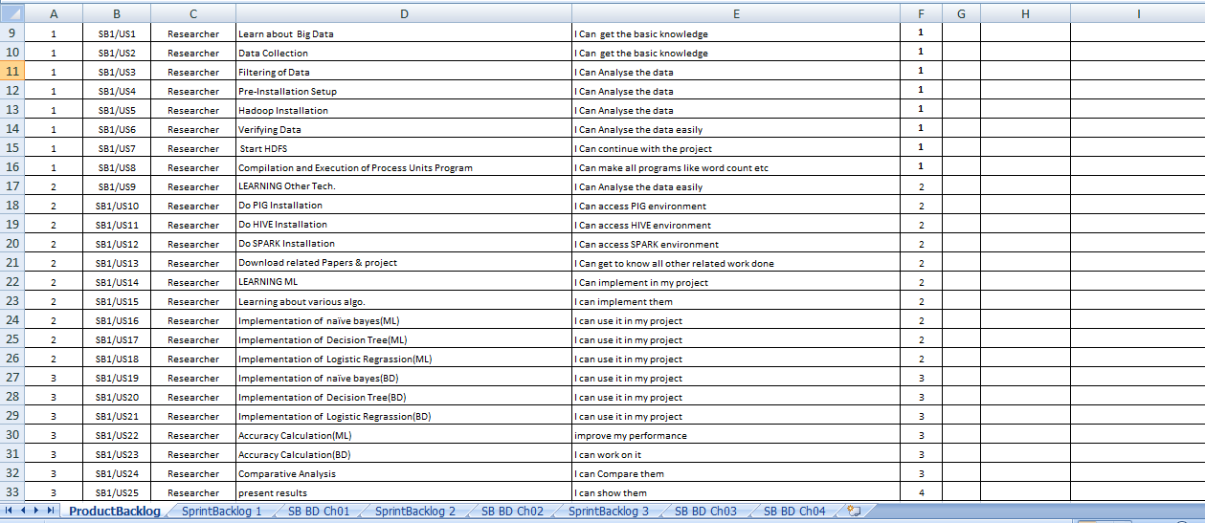

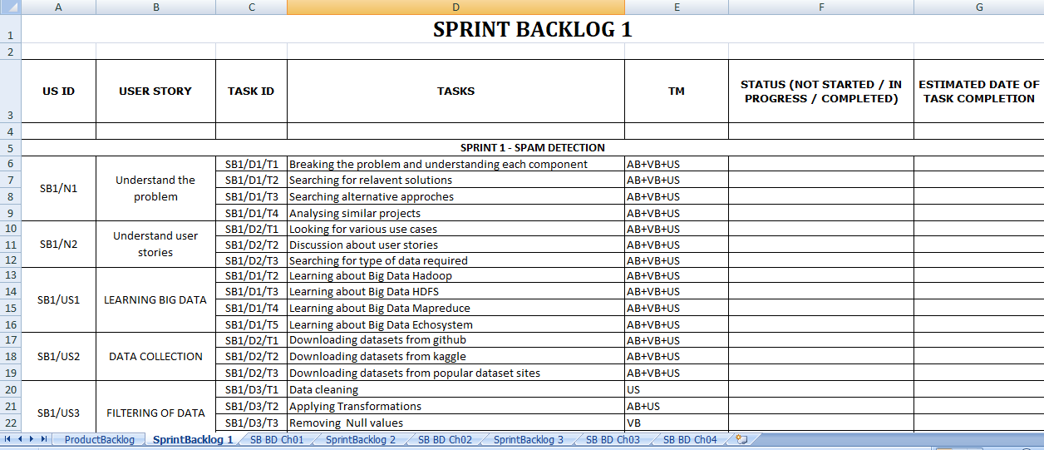

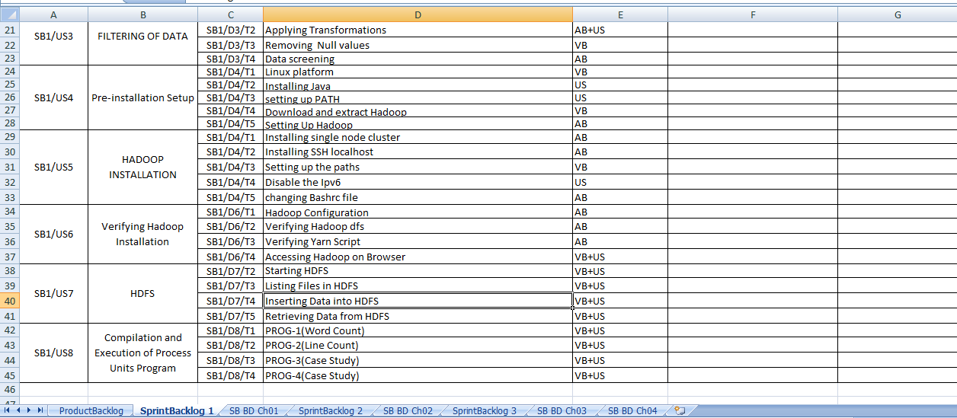

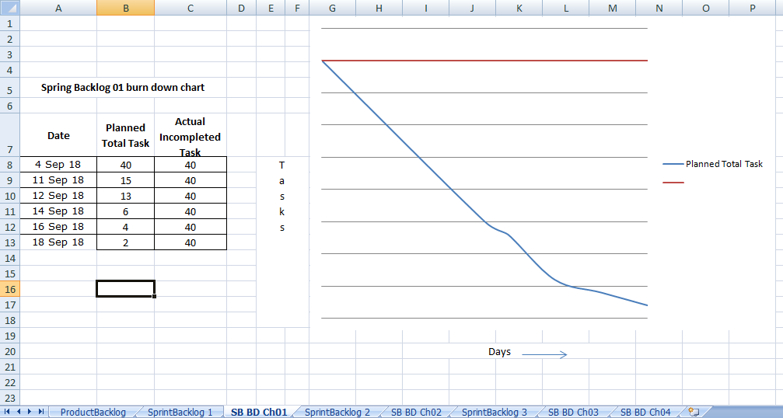

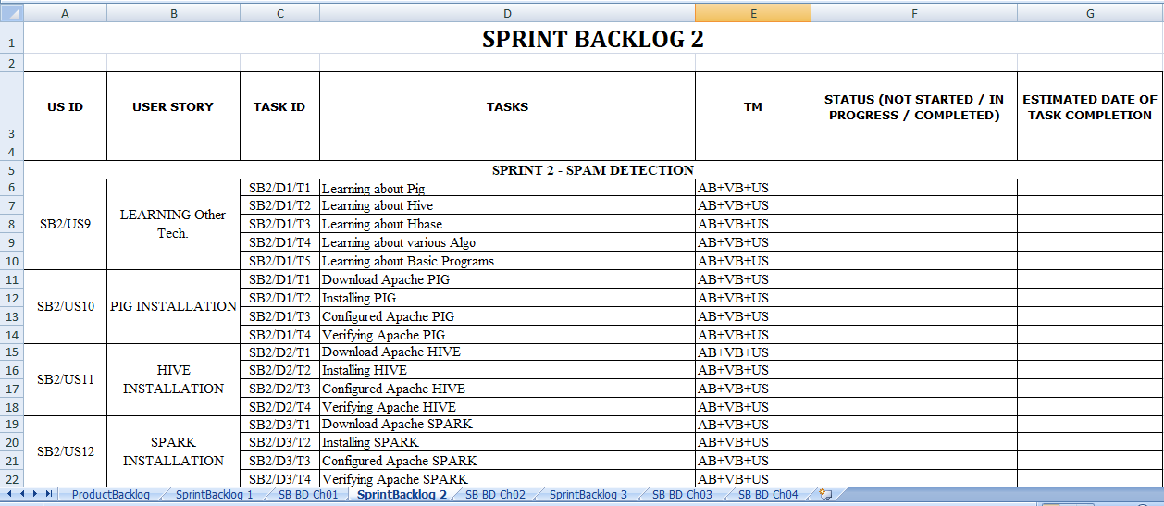

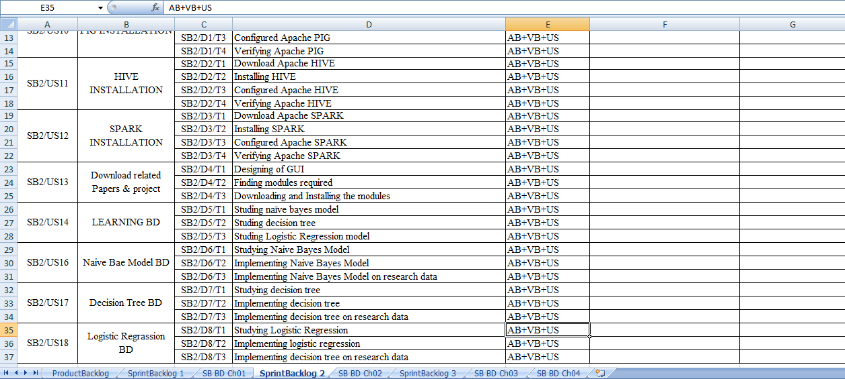

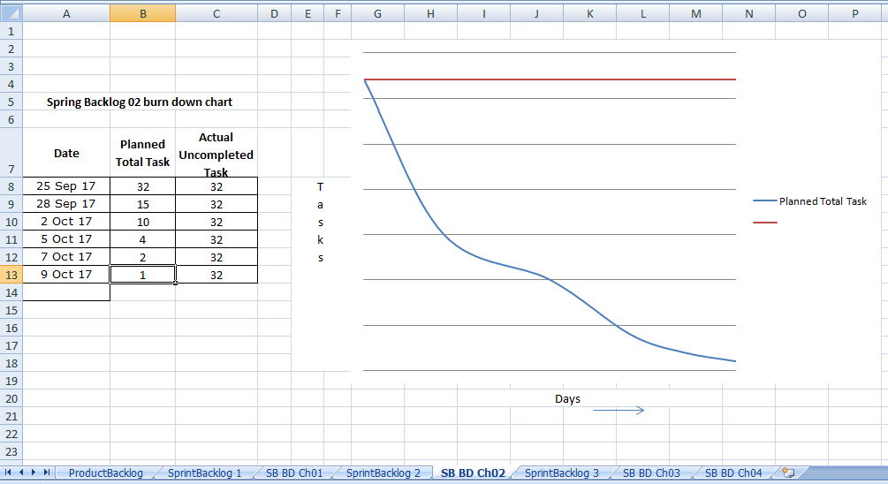

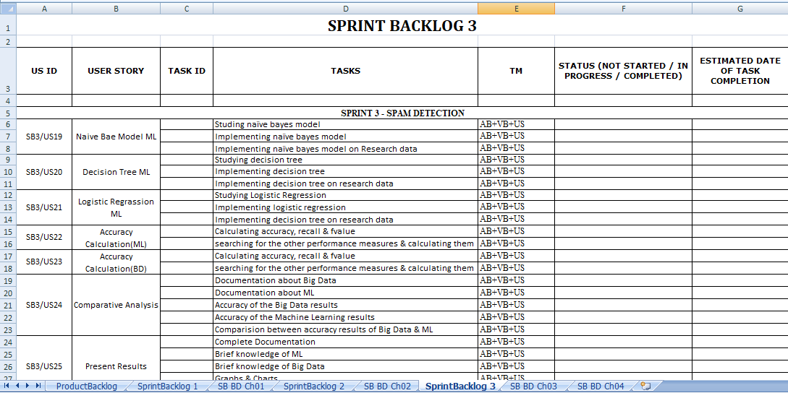

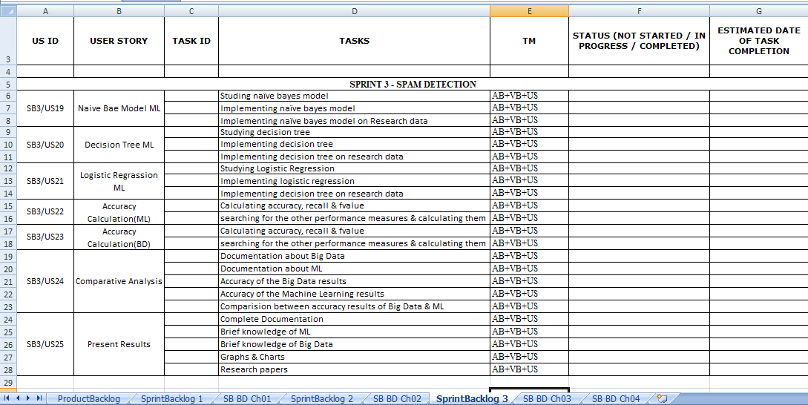

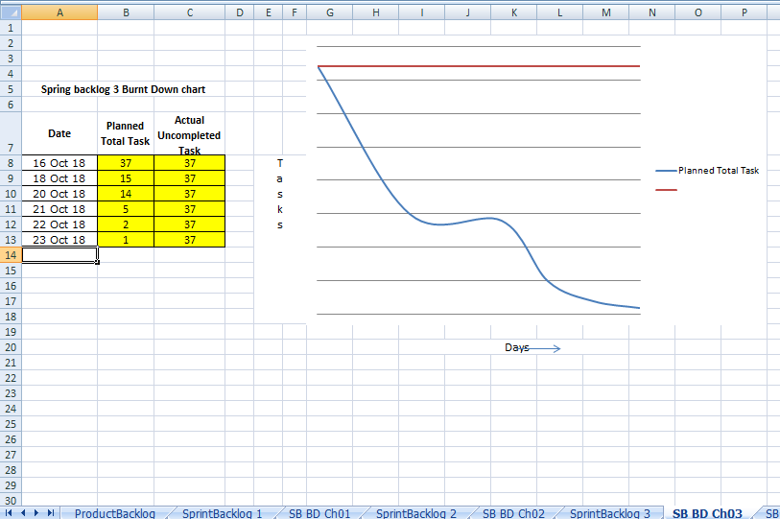

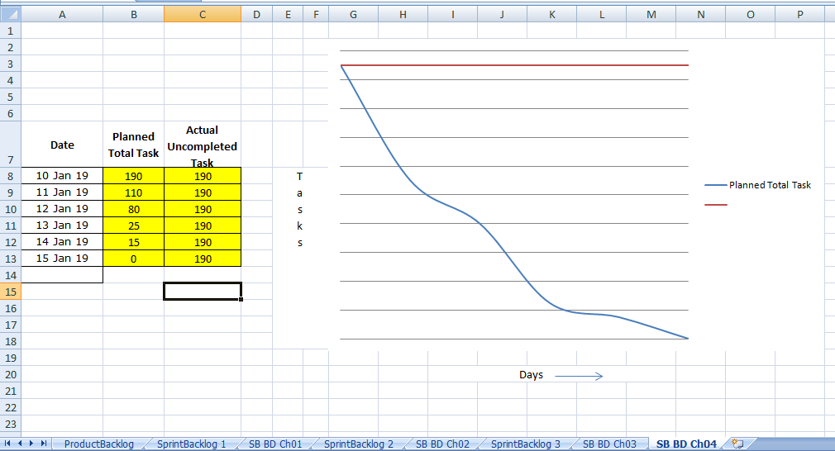

**CHAPTER 3**

**TECHNOLOGY APPLIED AND PROJECT MANAGEMENT**

**Brief Description of Technologies**

a) What is Hadoop?

Apache Hadoop is an Open Source software framework for storage and large-scale processing of data-sets on a clusters of commodity hardware. It is an Open source Data Management software framework with scale-out storage and distributed processing. It is being built and used by a global community of contributors and users.

Apache Hadoop has been originated from Google’s Whitepapers:

1. Apache HDFS is derived from GFS (Google File System).
2. Apache MapReduce s derived from Google MapReduce
3. Apache HBase is derived from Google BigTable.

Though Google has only provided the Whitepapers, without any implementation, around 90-95% of the architecture presented in these Whitepapers is applied in these three Java-based Apache projects.

HDFS and MapReduce are the two major components of Hadoop, where HDFS is from the ‘Infrastructural’ point of view and MapReduce is from the ‘Programming’ aspect. Though HDFS is at present a subproject of Apache Hadoop, it was formally developed as an infrastructure for the Apache Nutch web search engine project.

To understand the magic behind the scalability of Hadoop from one-node cluster to a thousand-nodes cluster (Yahoo! has 4,500-node cluster managing 40 petabytes of enterprise data), we need to first understand Hadoop’s file system, that is, HDFS (Hadoop Distributed File System).

#### b) What is HDFS (Hadoop Distributed File System)?

HDFS is a distributed and scalable file system designed for storing very large files with streaming data access patterns, running clusters on commodity hardware.Though it has many similarities with existing traditional distributed file systems, there are noticeable differences between these.

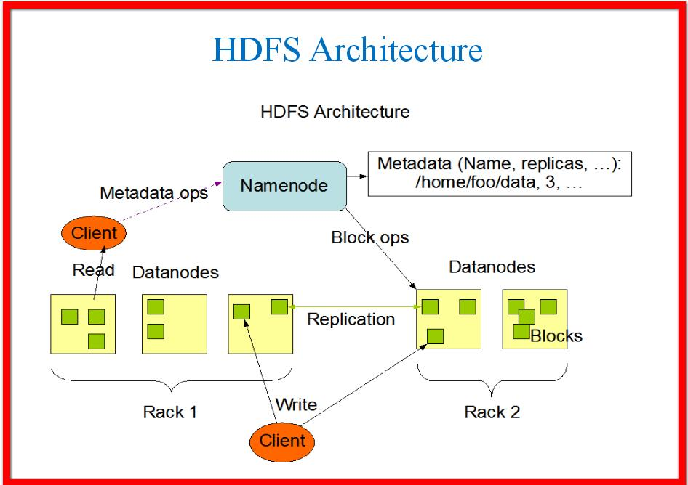

#### FIGURE- 2.1 Hadoop Distributed File System Architecture

#### Goals/Objectives behind HDFS:

#### 1. Large Data Sets.

#### 2.Write Once, Read Many Model.

#### 3. Streaming Data Access.

#### 4.Commodity Hardware.

#### 5.Data Replication and Fault Tolerance.

#### 6. High Throughput.

## c) HADOOP ECOSYSTEM

Hadoop Ecosystem is neither a programming language nor a service, it is a platform or framework which solves big data problems.

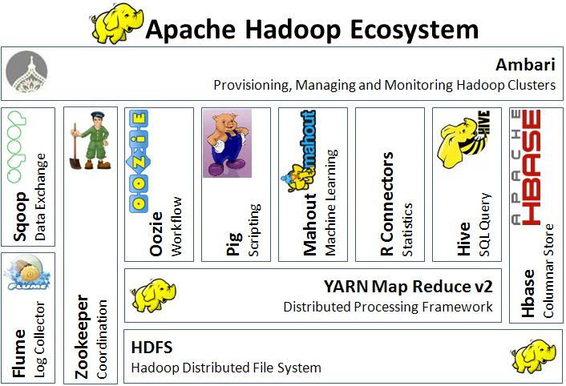

FIGURE-2.2 Hadoop Echosystem

.HDFS->Hadoop Distributed File System

* [YARN](https://www.edureka.co/blog/hadoop-ecosystem#yarn)->Yet Another Resource Negotiator
* MapReduce->Data processing using programming
* Spark-> In-memory Data Processing
* PIG, HIVE->Data Processing Services using Query (SQL-like)
* HBase->NoSQL Database
* Mahout, Spark MLlib ->Machine Learning
* Apache Drill->SQL on Hadoop
* [Zookeeper](https://www.edureka.co/blog/hadoop-ecosystem#apache_zookeeper)->Managing Cluster
* Oozie->Job Scheduling
* Flume, Sqoop->Data Ingesting Services
* Solr & Lucene ->Searching & Indexing
* Ambari ->Provision, Monitor and Maintain cluster

## 2.1 MAPREDUCE :

**MapReduce is a software framework which helps in writing applications that processes large data sets using distributed and parallel algorithms inside Hadoop environment.**

* In a MapReduce program, Map() and Reduce() are two functions.
  1. The Map function performs actions like filtering, grouping and sorting.
  2. While Reduce function aggregates and summarizes the result produced by map function.
  3. The result generated by the Map function is a key value pair (K, V) which acts as the input for Reduce function.

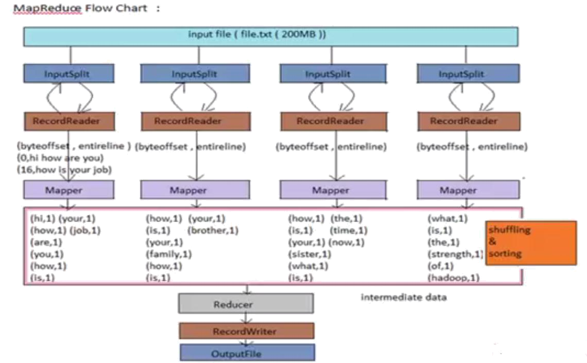

FIGURE-2.3 Map-Reduce Flowchart

**Machine Learning :**

Machine learning is an application of artificial intelligence (AI) that provides systems the ability to automatically learn and improve from experience without being explicitly programmed. **Machine learning focuses on the development of computer programs** that can access data and use it learn for themselves.

The process of learning begins with observations or data, such as examples, direct experience, or instruction, in order to look for patterns in data and make better decisions in the future based on the examples that we provide. **The primary aim is to allow the computers learn automatically** without human intervention or assistance and adjust actions accordingly.

### Some machine learning methods

Machine learning algorithms are often categorized as supervised or unsupervised.

* **Supervised machine learning algorithms**can apply what has been learned in the past to new data using labeled examples to predict future events. Starting from the analysis of a known training dataset, the learning algorithm produces an inferred function to make predictions about the output values. The system is able to provide targets for any new input after sufficient training. The learning algorithm can also compare its output with the correct, intended output and find errors in order to modify the model accordingly.
* In contrast, **unsupervised machine learning algorithms**are used when the information used to train is neither classified nor labeled. Unsupervised learning studies how systems can infer a function to describe a hidden structure from unlabeled data. The system doesn’t figure out the right output, but it explores the data and can draw inferences from datasets to describe hidden structures from unlabeled data.
* **Semi-supervised machine learning algorithms** fall somewhere in between supervised and unsupervised learning, since they use both labeled and unlabeled data for training – typically a small amount of labeled data and a large amount of unlabeled data. The systems that use this method are able to considerably improve learning accuracy. Usually, semi-supervised learning is chosen when the acquired labeled data requires skilled and relevant resources in order to train it / learn from it. Otherwise, acquiringunlabeled data generally doesn’t require additional resources.
* **Reinforcement machine learning algorithms**is a learning method that interacts with its environment by producing actions and discovers errors or rewards. Trial and error search and delayed reward are the most relevant characteristics of reinforcement learning. This method allows machines and software agents to automatically determine the ideal behavior within a specific context in order to maximize its performance. Simple reward feedback is required for the agent to learn which action is best; this is known as the reinforcement signal.

Machine learning enables analysis of massive quantities of data. While it generally delivers faster, more accurate results in order to identify profitable opportunities or dangerous risks, it may also require additional time and resources to train it properly. Combining machine learning with AI and cognitive technologies can make it even more effective in processing large volumes of information.

**Project management :**

Project management is the application of processes, methods, knowledge, skills and experience to achieve the project objectives. General. A project is a unique, transient endeavor, undertaken to achieve planned objectives, which could be defined in terms of outputs, outcomes or benefits.

Project management is the practise of initiating, planning, executing, controlling, and closing the [work](https://en.wikipedia.org/wiki/Work_(project_management)) of a [team](https://en.wikipedia.org/wiki/Project_team) to achieve specific goals and meet specific success criteria at the specified time. A [project](https://en.wikipedia.org/wiki/Project) is a temporary endeavor designed to produce a unique product, service or result with a defined beginning and end undertaken to meet unique goals and objectives, typically to bring about beneficial change or added value. The temporary nature of projects stands in contrast with [business as usual](https://en.wikipedia.org/wiki/Business_operations), which are repetitive, permanent, or semi-permanent functional activities to produce products or services. In practice, the [management](https://en.wikipedia.org/wiki/Management) of such distinct production approaches requires the development of distinct technical skills and management strategies.

**Software project management**

Software project management is the art and science of planning and leading software projects. It is a sub-discipline of [project management](https://en.wikipedia.org/wiki/Project_management) in which [software](https://en.wikipedia.org/wiki/Software) projects are planned, implemented, monitored and controlled.

The job pattern of an IT company engaged in software development can be seen split in two parts:

* Software Creation
* Software Project Management

A project is well-defined task, which is a collection of several operations done in order to achieve a goal (for example, software development and delivery). A Project can be characterized as:

* Every project may have a unique and distinct goal.
* Project is not routine activity or day-to-day operations.
* Project comes with a start time and end time.
* Project ends when its goal is achieved hence it is a temporary phase in the lifetime of an organization.
* Project needs adequate resources in terms of time, manpower, finance, material and knowledge-bank.

**Software Project**

A Software Project is the complete procedure of software development from requirement gathering to testing and maintenance, carried out according to the execution methodologies, in a specified period of time to achieve intended software product.

**Need of software project management**

Software is said to be an intangible product. Software development is a kind of all new stream in world business and there’s very little experience in building software products. Most software products are tailor made to fit client’s requirements. The most important is that the underlying technology changes and advances so frequently and rapidly that experience of one product may not be applied to the other one. All such business and environmental constraints bring risk in software development hence it is essential to manage software projects efficiently.

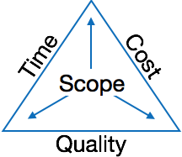

The image above shows triple constraints for software projects. It is an essential part of software organization to deliver quality product, keeping the cost within client’s budget constrain and deliver the project as per scheduled. There are several factors, both internal and external, which may impact this triple constrain triangle. Any of three factor can severely impact the other two.

Therefore, software project management is essential to incorporate user requirements along with budget and time constraints.

**Software Project Manager**

A software project manager is a person who undertakes the responsibility of executing the software project. Software project manager is thoroughly aware of all the phases of SDLC that the software would go through. Project manager may never directly involve in producing the end product but he controls and manages the activities involved in production.

A project manager closely monitors the development process, prepares and executes various plans, arranges necessary and adequate resources, maintains communication among all team members in order to address issues of cost, budget, resources, time, quality and customer satisfaction.

Let us see few responsibilities that a project manager shoulders -

**Managing People**

* Act as project leader
* Liaison with stakeholders
* Managing human resources
* Setting up reporting hierarchy etc.

**Managing Project**

* Defining and setting up project scope
* Managing project management activities
* Monitoring progress and performance
* Risk analysis at every phase
* Take necessary step to avoid or come out of problems
* Act as project spokesperson

**Software Management Activities**

Software project management comprises of a number of activities, which contains planning of project, deciding scope of software product, estimation of cost in various terms, scheduling of tasks and events, and resource management. Project management activities may include:

* **Project Planning**
* **Scope Management**
* **Project Estimation**

**Project Planning**

Software project planning is task, which is performed before the production of software actually starts. It is there for the software production but involves no concrete activity that has any direction connection with software production; rather it is a set of multiple processes, which facilitates software production. Project planning may include the following:

**Scope Management**

It defines the scope of project; this includes all the activities, process need to be done in order to make a deliverable software product. Scope management is essential because it creates boundaries of the project by clearly defining what would be done in the project and what would not be done. This makes project to contain limited and quantifiable tasks, which can easily be documented and in turn avoids cost and time overrun.

During Project Scope management, it is necessary to -

* Define the scope
* Decide its verification and control
* Divide the project into various smaller parts for ease of management.
* Verify the scope
* Control the scope by incorporating changes to the scope

**Project Estimation**

For an effective management accurate estimation of various measures is a must. With correct estimation managers can manage and control the project more efficiently and effectively.

Project estimation may involve the following:

* **Software size estimation**

Software size may be estimated either in terms of KLOC (Kilo Line of Code) or by calculating number of function points in the software. Lines of code depend upon coding practices and Function points vary according to the user or software requirement.

* **Effort estimation**

The managers estimate efforts in terms of personnel requirement and man-hour required to produce the software. For effort estimation software size should be known. This can either be derived by managers’ experience, organization’s historical data or software size can be converted into efforts by using some standard formulae.

* **Time estimation**

Once size and efforts are estimated, the time required to produce the software can be estimated. An effort required is segregated into sub categories as per the requirement specifications and interdependency of various components of software. Software tasks are divided into smaller tasks, activities or events by Work Breakthrough Structure (WBS). The tasks are scheduled on day-to-day basis or in calendar months.

The sum of time required to complete all tasks in hours or days is the total time invested to complete the project.

* **Cost estimation**

This might be considered as the most difficult of all because it depends on more elements than any of the previous ones. For estimating project cost, it is required to consider -

* + Size of software
  + Software quality
  + Hardware
  + Additional software or tools, licenses etc.
  + Skilled personnel with task-specific skills
  + Travel involved
  + Communication
  + Training and support

**Project Estimation Techniques**

We discussed various parameters involving project estimation such as size, effort, time and cost.Project manager can estimate the listed factors using two broadly recognized techniques

**Decomposition Technique**

This technique assumes the software as a product of various compositions.

There are two main models -

* **Line of Code** Estimation is done on behalf of number of line of codes in the software product.
* **Function Points** Estimation is done on behalf of number of function points in the software product.

**Empirical Estimation Technique**

This technique uses empirically derived formulae to make estimation.These formulae are based on LOC or FPs.

* **Putnam Model**

This model is made by Lawrence H. Putnam, which is based on Norden’s frequency distribution (Rayleigh curve). Putnam model maps time and efforts required with software size.

* **COCOMO**

COCOMO stands for COnstructiveCOstMOdel, developed by Barry W. Boehm. It divides the software product into three categories of software: organic, semi-detached and embedded.

**Project Scheduling**

Project Scheduling in a project refers to roadmap of all activities to be done with specified order and within time slot allotted to each activity. Project managers tend to define various tasks, and project milestones and they arrange them keeping various factors in mind. They look for tasks lie in critical path in the schedule, which are necessary to complete in specific manner and strictly within the time allocated. Arrangement of tasks which lies out of critical path are less likely to impact over all schedule of the project.

For scheduling a project, it is necessary to -

* Break down the project tasks into smaller, manageable form
* Find out various tasks and correlate them
* Estimate time frame required for each task
* Divide time into work-units
* Assign adequate number of work-units for each task
* Calculate total time required for the project from start to finish

**Resource management**

All elements used to develop a software product may be assumed as resource for that project. This may include human resource, productive tools and software libraries.

The resources are available in limited quantity and stay in the organization as a pool of assets. The shortage of resources hampers the development of project and it can lag behind the schedule. Allocating extra resources increases development cost in the end. It is therefore necessary to estimate and allocate adequate resources for the project.

Resource management includes -

* Defining proper organization project by creating a project team and allocating responsibilities to each team member
* Determining resources required at a particular stage and their availability
* Manage Resources by generating resource request when they are required and de-allocating them when they are no more needed.

**Project Risk Management**

Risk management involves all activities pertaining to identification, analysing and making provision for predictable and non-predictable risks in the project. Risk may include the following:

* Experienced staff leaving the project and new staff coming in.
* Change in organizational management.
* Requirement change or misinterpreting requirement.
* Under-estimation of required time and resources.
* Technological changes, environmental changes, business competition.

**Risk Management Process**

There are following activities involved in risk management process:

* **Identification -** Make note of all possible risks, which may occur in the project.
* **Categorize -** Categorize known risks into high, medium and low risk intensity as per their possible impact on the project.
* **Manage -** Analyze the probability of occurrence of risks at various phases. Make plan to avoid or face risks. Attempt to minimize their side-effects.
* **Monitor -** Closely monitor the potential risks and their early symptoms. Also monitor the effects of steps taken to mitigate or avoid them.

**Project Execution & Monitoring**

In this phase, the tasks described in project plans are executed according to their schedules.

Execution needs monitoring in order to check whether everything is going according to the plan. Monitoring is observing to check the probability of risk and taking measures to address the risk or report the status of various tasks.

These measures include -

* **Activity Monitoring -** All activities scheduled within some task can be monitored on day-to-day basis. When all activities in a task are completed, it is considered as complete.
* **Status Reports -** The reports contain status of activities and tasks completed within a given time frame, generally a week. Status can be marked as finished, pending or work-in-progress etc.
* **Milestones Checklist -** Every project is divided into multiple phases where major tasks are performed (milestones) based on the phases of SDLC. This milestone checklist is prepared once every few weeks and reports the status of milestones.

**Project Communication Management**

Effective communication plays vital role in the success of a project. It bridges gaps between client and the organization, among the team members as well as other stake holders in the project such as hardware suppliers.

Communication can be oral or written. Communication management process may have the following steps:

* **Planning** - This step includes the identifications of all the stakeholders in the project and the mode of communication among them. It also considers if any additional communication facilities are required.
* **Sharing** - After determining various aspects of planning, manager focuses on sharing correct information with the correct person on correct time. This keeps every one involved the project up to date with project progress and its status.
* **Feedback** - Project managers use various measures and feedback mechanism and create status and performance reports. This mechanism ensures that input from various stakeholders is coming to the project manager as their feedback.
* **Closure** - At the end of each major event, end of a phase of SDLC or end of the project itself, administrative closure is formally announced to update every stakeholder by sending email, by distributing a hardcopy of document or by other mean of effective communication.

After closure, the team moves to next phase or project.

**Configuration Management**

Configuration management is a process of tracking and controlling the changes in software in terms of the requirements, design, functions and development of the product.

IEEE defines it as “the process of identifying and defining the items in the system, controlling the change of these items throughout their life cycle, recording and reporting the status of items and change requests, and verifying the completeness and correctness of items”.

Generally, once the SRS is finalized there is less chance of requirement of changes from user. If they occur, the changes are addressed only with prior approval of higher management, as there is a possibility of cost and time overrun.

**Project management Tools:**

Project management required tools to manage the work , time and resources. At present many of the software are available for project management. Some of the popular software tools are as follows.

### 01. [Trello](http://send.getapp.com/aff_c?offer_id=677&aff_id=1371)

Trello is an project management tool, instead this app is a free visual way to to glance at the entire project with a single view. With Trello you can organise cards, these cards can be your thoughts, conversations and to-do lists and be placed on a board for everyone to collaborate on.

### 02. [Basecamp](http://send.getapp.com/aff_c?offer_id=637&aff_id=1371)

Basecamp is the granddaddy of project management apps. Basecamp is considered the leading project management tool around. It boost a simple and easy to use interface to collaborate with your team and client. It allows you to create multiple projects and setup discussions, write to-do lists, manage files, create and share documents, and organise dates for scheduling.

### 03. [Teamwork Projects](http://send.getapp.com/aff_c?offer_id=947&aff_id=1371)

Teamwork Projects is the ultimate productivity tool to manage projects with your team. Teamwork allows you to keep all your projects, tasks and files all in one place and easily collaborate with a team. Teamwork helps you to visualise the entire project through a marked calendar and gantt chart and setup reporting. Teamwork supports file management with Google Drive, Box.com and Dropbox. As well as integration with leading apps such as third party accounting software and customer support apps.

### 04. [Resource Guru](https://resourceguruapp.com/)

Billed as the "simple way to schedule people, equipment and other resources", Resource Guru is a streamlined resource scheduling and leave management tool that’s designed to keep your projects on track. You can plan your team's workloads, receive daily booking reminders, report on KPIs, and more. Apple, Saatchi & Saatchi and Deloitte are among some of the cloud-based team calendar’s heavyweight customers.

### 05. [Active Collab](http://send.getapp.com/aff_c?offer_id=949&aff_id=1371)

ActiveCollab recently released its new version 5.0. The new revamped app is now more powerful and focused project management tool. It offers team collaborating features, task management, time tracking and importing expenses. One of the biggest asset of ActiveCollab is it offers invoicing features. You are able to track payments and expenses and have invoices paid directly within ActiveCollab with PayPal, and other credit card payments.

### 06. [Zoho Projects](http://send.appdoubler.com/aff_c?offer_id=101&aff_id=1371)

Zoho offers a wide range of business software including Projects. Zoho Projects is an proficient tool to project plan and project coordinator from start to finish. It boost all the features you need for project management with some advance features including reporting, integration with Google Apps and Dropbox, bug tracking, setup Wiki Pages to build a repository of information, forums and more.

### 07. [Jira](http://send.getapp.com/aff_c?offer_id=281&aff_id=1371)

Jira is specifically targeted for software development teams. Jira offers abilities to raise issues and bugs. Jira makes it real easy to track bugs and see which issues are still outstanding and how much time was spent on each task. Jira offer other products including Confluence a document collaboration tool, and HipChat a team chat and video and file sharing platform and other products.

### 08. [Asana](http://send.getapp.com/aff_c?offer_id=587&aff_id=1371)

Asana is the easiest way for teams to track their work so everyone knows who's doing what, by when. With tasks, projects, conversations and dashboards, Asana keeps your work organized, and teammates accountable so you can move work forward faster. Asana also lets you keep track of your work wherever you are with mobile apps for both iOS and Android.

### 09. [Podio](http://send.getapp.com/aff_c?offer_id=951&aff_id=1371)

Podio is a ever growing tool to organise and communication tool for any business. Podio allows you to personalise this platform to fit your business needs. Besides being able to communicate with a team, setup task management, use as a file storage system, like a traditional project management app, Podio can be an internal intranet for all your colleagues and departments to interact.

### 10. [Freedcamp](https://freedcamp.com/)

Whatever your project may be, either setting up an event, a web project or organising a wedding, Freedcamp helps you organise and plan effectively. Freedcamp has an organised dashboard to view the entire project at a glance. You can easily setup tasks, use sticky notes to visually setup tasks and organise them into the calendar. Freedcamp provides advance add-ons for high level business use including CRM, invoicing, issue tracking and setting up wiki pages.

### 11. [Wrike](http://send.getapp.com/aff_c?offer_id=239&aff_id=1371)

Wrike is advance application to help you work smarter. By making sure you are always staying on track and ensure you have the adequate resources to finish on time and on budget.Setting up tasks, engage your team and integrate with your business tools including Google Apps, Microsoft Excel, Dropbox and many more is so easy with Wrike.

**PO and Their Relevance to project**

**PO1: Engineering knowledge:**Apply the knowledge of mathematics, science, engineering fundamentals and an engineering specialization to the solution of complex engineering problems.

In this project creation process engineering knowledge of the software engineering and Electronics engineering have been applied. we have used software engineering , HTML,xml, java , android , java script , php , j2ee, data base , oracle , my sql , mango and other programming language and database to the project. We have applied all above engineering subjects in our projects.

**PO2: Problem analysis:**Identify, formulate, review research literature, and analyze complex engineering problems reaching substantiated conclusions using first principles of mathematics, natural sciences, and engineering sciences.

In our projects we have identified an problem , once verified by the client we have worked to identify the solution using all of our theoretical and practical knowledge.

**PO3: Design/development of solutions:** Design solutions for complex engineering problems and design system components or processes that meet the specified needs with appropriate consideration for the public health and safety, and the cultural, societal, and environmental considerations.

**PO4: Conduct investigations of complex problems:** Use research-based knowledge and research methods including design of experiments, analysis and interpretation of data, and synthesis of the information to provide valid conclusions.

**PO5: Modern tool usage:**Create, select, and apply appropriate techniques, resources, and modern engineering and IT tools including prediction and modeling to complex engineering activities with an understanding of the limitations.

In the project development we have applied Integrated Development Environment IDE for the rapid development of the code, used web server for the software development.

**PO6: The engineer and society**: Apply reasoning informed by the contextual knowledge to assess societal, health, safety, legal and cultural issues and the consequent responsibilities relevant to the professional engineering practice.

In 1961 , the Conference of Engineering Societies of Western Europe and the United States of America defined "professional engineer" as follows.

A professional engineer is competent by virtue of his/her fundamental education and training to apply the scientific method and outlook to the analysis and solution of engineering problems. He/she is able to assume personal responsibility for the development and application of engineering science and knowledge, notably in research, design, construction, manufacturing, superintending, managing and in the education of the engineer. His/her work is predominantly intellectual and varied and not of a routine mental or physical character. It requires the exercise of original thought and judgement and the ability to supervise the technical and administrative work of others. His/her education will have been such as to make him/her capable of closely and continuously following progress in his/her branch of engineering science by consulting newly published works on a worldwide basis, assimilating such information and applying it independently. He/she is thus placed in a position to make contributions to the development of engineering science or its applications. His/her education and training will have been such that he/she will have acquired a broad and general appreciation of the engineering sciences as well as thorough insight into the special features of his/her own branch. In due time he/she will be able to give authoritative technical advice and to assume responsibility for the direction of important tasks in his/her branch.

**PO7: Environment and sustainability:** Understand the impact of the professional engineering solutions in and environmental contexts, and demonstrate the knowledge of, and need for sustainable development.

Sustainability is the ability to continue a defined behavior indefinitely. Sometimes environmental, social and economic are termed to be the three pillars of sustainability.

**PO8: Ethics**: Apply ethical principles and commit to professional ethics and responsibilities and norms of the engineering practice

The ethics of engineers and the fundamental principles for Engineers are as follows.

Engineers uphold and advance the integrity, honor and dignity of the engineering profession by:

I. using their knowledge and skill for the enhancement of human welfare;

II.being honest and impartial, and servicing with fidelity the public, their employers and clients;

III. Striving to increase the competence and prestige of the engineering profession; and

IV. Supporting the professional and technical societies of their disciplines.   
  
  
**PO9. Individual and team work**: Function effectively as an individual and as a member or leader in diverse teams, and in multidisciplinary settings.  
  
  
To work successful in team a team member must have following capabilities.

**1. The Ability to Listen**

it is important to listen to one another's ideas. Too often in a business setting, you have a group of people simply waiting for their turn to speak, not paying one iota of attention to the persons on their left or right. So it is a good teamwork skill to have the ability to listen

**2. Check Your Ego**

This isn't saying abandon your ego all together, because that isn't healthy. But leaving your ego at the door temporarily is a very important team work skill. The reason this is so essential is because there is always someone better than you at something, no matter how brilliant you are.

**3. Critique**

By critique, I mean constructive criticism. Be able to give others constructive criticism and be able to listen to others critique your ideas and work. There shouldn't be any offense taken to constructive criticism. You all want to succeed, and this is a vital step in doing so.

**4. Delegation**

The mentality must be applied to teamwork. Delegate roles to those who do them best.

**5. Show Respect**

If you and another person happen to be paired up and can't stand each other, you can still put that aside for a couple of hours, treat each other civilly, and complete the tasks at hand. You may even overcome the dislike toward one another.

**6. Be Helpful**

This is simple.If one of your teammates does not understand an idea, discussion, or task that is being completed, take the necessary time to explain it to them and work with them. There are no weak links when everyone helps one another. Some take longer to learn than others, but that doesn't mean that they are of less intelligence. If in a meeting someone asks a question because they don't understand, don't frown at them. Just answer the questions patiently and concisely.

**7. Question One Another**

If someone brings up a topic of discussion and a solution to this topic, question them. Respectfully question, don't badger. Rather, ask them how it will work, why it will work over the long-run, and how everyone else can implement the idea.

**8. Participation**

Have the entire team encourage shy people to engage in the topics of discussion. Don't demand it, but make them realize that you really want to hear their ideas.

**9. Rational Debate**

Bad ideas are bad for teams. Spirited, friendly, rational debate is where facts come forward, ideas are born, and quality rises to the top.

**10. Set The Right Environment**

Try to make the space in which your team is assembled as comfortable, relaxing, and inviting as possible. You do not want your team to be tense and with frayed nerves.

**PO 10: Communication:**Communicate effectively on complex engineering activities with the engineering community and with society at large, such as, being able to comprehend and write effective reports and design documentation, make effective presentations, and give and receive clear instructions.

**PO11: Project management and finance:**Demonstrate knowledge and understanding of the engineering management principles and apply these to one’s own work, as a member and leader in a team, to manage projects and in multidisciplinary environments.

Project management is the application of processes, methods, knowledge, skills and experience to achieve the project objectives. In general project is a unique, transient endeavour, undertaken to achieve planned objectives, which could be defined in terms of outputs, outcomes or benefits.

**PO12: Life-long learning**: Recognize the need for and have the preparation and ability to engage in independent and lifelong learning in the broadest context of technological change.

Life Long Learning means is the provision or use of both formal and informal learning opportunities throughout people's lives in order to foster the continuous development and improvement of the knowledge and skills needed for employment and personal fulfillment

**CHAPTER 4**

**PROJECT IMPLEMENTATION**

( Each Spring Backlog of 13-17 Pages total Chapter Size 50-70 pages)

1. Sprint Backlog-1  
     
   ( ***Project Design , Algo ,Database Design , ERD , Project Code ( Sample code only Limited to Max of 2-3 Page if needed , Project Screen Shots*** )
2. Sprint Backlog-2

( ***Project Design , Algo ,Database Design , ERD , Project Code ( Sample code only Limited to Max of 2-3 Page if needed , Project Screen Shots***

1. Sprint Backlog-3

( ***Project Design , Algo ,Database Design , ERD , Project Code ( Sample code only Limited to Max of 2-3 Page if needed , Project Screen Shots*** )

1. Sprint Backlog-4  
     
   ( ***Project Design , Algo ,Database Design , ERD , Project Code ( Sample code only Limited to Max of 2-3 Page if needed , Project Screen Shots*** )

**CHAPTER 5**

**CONCLUSION**

( 3 to 5 page)

Results

Conclusion

Future Scope

**ANNEXURES**

References

Research Paper ( if Presented and approved for publication)

DST Document presented for grants.

CV

**Instructions**

For Chapter Heading

Font: Times New Roman

Font Size: 14, Bold

Alignment: Center

Line Spacing 1.5

For Paragraph Heading

Font: Times New Roman

Font Size: 12, Bold

Alignment: Left

Line Spacing 1.5

For paragraph

Font: Times New Roman

Font Size: 12

Line Spacing 1.5

Alignment: Justify

Line Spacing 1.5